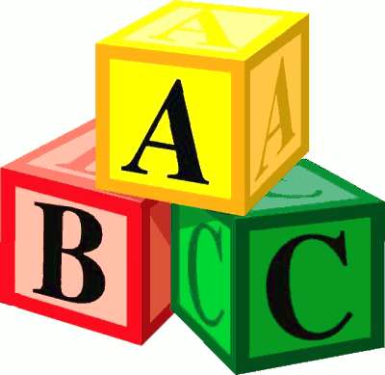
St. Timothy Catholic School
Four-Year-Old Class Objectives

St. Timothy preschool provides a warm introduction to your child’s schooling by celebrating and developing every student’s unique qualities within our Catholic environment. Our teachers see each individual as a child of God and are committed to nurturing spiritual, emotional, social, and academic development. Your child benefits from being a part of the larger St. Timothy Catholic School community with access to our large library, science lab, Spanish instruction, two playgrounds, gym, and sports field.

“Center-based” activities provide students with opportunities to learn while playing. This approach encourages each child to develop at his or her own unique pace. Learning through play increases comprehension and motivation to learn because it relates new concepts to a child’s experiences. Children are encouraged to think, reason, question, and experiment in age-appropriate activities. STS is proud that each preschool classroom is equipped with SMART Boards to enhance learning. Our curriculum is vertically aligned; skills are initially introduced in the three-year-old program and then expanded in the four-year-old classes in order to prepare students for their kindergarten experience.

Faith Formation
- Daily opportunities to grow in God’s love
- Learning fundamental Catholic prayers
- Visiting the church and grotto connects students to the wider Church community
- Monthly Eucharistic Adoration

School Readiness Skills
- Entering the classroom independently and hanging up backpack
- Learning to put on coats, zip them, and hang them up when done
- Cleaning up after self
- Expressing needs and ideas to teachers and peers
- Trying new things willingly

Cognitive Skills
- Learning the foundations of math concepts (counting, sorting, size)
- Learning basic science concepts through hands-on activities
- Identifying shapes, colors, and numbers 1-25
- Completing 8-15 piece puzzles
- Increasing attention span
- Applying technology to support learning objectives

Social/Emotional Skills
- Taking turns and developing sharing skills
- Functioning within a school setting
- Learning to enter into a group of playing children
- Learning to work cooperatively

Pre-Reading Skills
- Learning upper-case and lower-case letters
- Relating letter sounds to letters
- Sequencing events
- Learning rhyming words and nursery rhymes
- Visiting the school library for story time

Language Development
- Communicating ideas to teachers and friends
- Using words to express emotions
- Following three-step directions
- Speaking in front of a group (show and tell, student of the week, etc.)
- Introducing Spanish with Senora Dee

Small Motor Skills
- Strengthening fingers in preparation for writing
- Stringing beads
- Introducing correct pencil grip
- Using scissors correctly and following a general line

Large Motor Skills
- Balancing on one foot
- Hopping
- Skipping
- Throwing and catching a ball

St. Timothy Catholic School
Experience the difference!

