1.jpgE:\dcinalli\AppData\Local\Microsoft\Windows\Temporary Internet Files\Content.IE5\4E2GFEPX\MC900411244[1].wmfE:\dcinalli\AppData\Local\Microsoft\Windows\Temporary Internet Files\Content.IE5\4E2GFEPX\MC900411244[1].wmf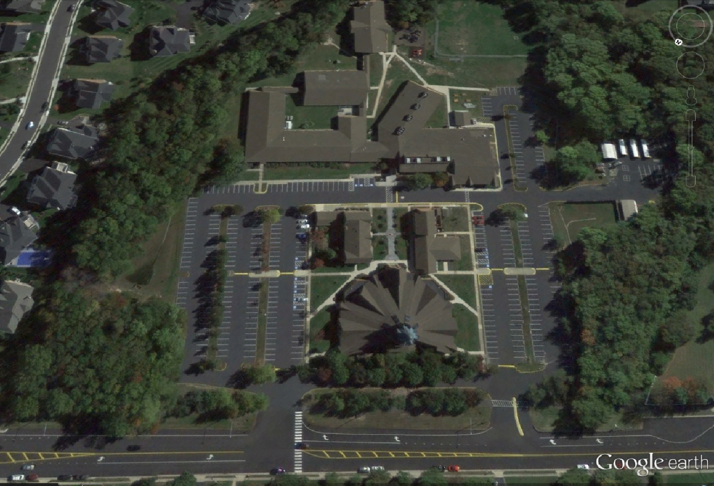

2. The preschool lane continues straight and drives along the side of the cafeteria. Here you will drop off all of your children. Assistants and patrols will be on hand to help the preschoolers out of the car, into the school, and to their classrooms. When the traffic guard instructs you to pull forward, you will follow the traffic in front of the school and leave the parking lot.

3. The kindergarten through eighth grade lane turns left to drive in front of the school. Pay attention to the traffic guard and obey his/her instructions. Once you are in front of the school and have come to a complete stop, you may unload your students. Once they are out of the car and safely on the curb, pull ahead and exit the parking lot.

1. When you get to the far right parking bay, break into two lanes. The left lane (green) is for cars that have students in kindergarten through eighth grade. The right lane (yellow) is for any cars the have a preschooler, if you have a preschooler and older children, go in the preschool lane.

**2**

**Cafeteria**

**3**

**Front of school entrance**

 Any car with a preschooler

Car with K-8 students only

**1**