OFFICE OF CATHOLIC SCHOOLS DIOCESE OF ARLINGTON

SEVERE ALLERGY/ANAPHYLAXIS ACTION PLAN & TREATMENT AUTHORIZATION

PART I - TO BE COMPLETED BY PARENT

Student ________________________________ Date of Birth_________ Teacher/Grade________________
Allergy __________________________ ⁯
Route of Exposure Contact Ingestion
Inhalation Sting
Weight _____________lbs.

Asthmatic Yes* No *Higher risk for severe reaction Parent / Guardian Initials ________________

PART II - TO BE COMPLETED BY LICENSED HEALTH CARE PROVIDER
⁯If checked, give epinephrine immediately for ANY symptoms if the allergen was likely eaten / contacted.
⁯ If checked, give epinephrine immediately if the allergen was definitely eaten or contacted even if no symptoms are noted.
- INJECT EPINEPHRINE IMMEDIATELY

- Call 911

- Begin monitoring

- Give additional medications if applicable

  - Antihistamines
  - Inhaler

Antihistamines and Inhalers are not to be depended upon to treat a severe reaction.
USE EPINEPHRINE
FOR ANY OF THE FOLLOWING: SEVERE SYMPTOMS

One or more of the following:

LUNG Short of Breath, wheeze, repetitive cough

HEART Pale, blue, faint, weak pulse, dizzy, confused

THROAT Tight, hoarse, trouble breathing or swallowing

MOUTH Obstructive swelling (tongue or lips)

SKIN Many hives over body

Or combination of symptoms from different body areas

SKIN Hives, itchy rashes, swelling

GUT Vomiting, cramps, pain

- GIVE ANTIHISTAMINE if ordered

- Stay with student, alert parent

- If symptoms progress see above

- Begin monitoring
MILD SYMPTOMS ONLY

MOUTH Itchy mouth

SKIN A few hives around mouth/face mild itch

GUT Mild nausea/discomfort

MEDICATIONS / DOSES:

Epinephrine Auto-Injector (brand and dose): __________________________________________________________

Antihistamine (brand and dose): ____________________________________________________________________
(Antihistamines should NOT be used as a first line of treatment during an anaphylaxis episode. It will treat itching ONLY-it will not halt vascular collapse or swelling!)

Other (e.g., Inhaler-bronchodilator if wheezing)________________________________________________________

It is my professional opinion that this student SHOULD/SHOULD NOT carry his/her epinephrine auto-injector.

________________________________ ____________________________________ ________________ _____________
Licensed Health Care Provider (Print) Licensed Health Care Provider (Signature) Telephone Date

OFFICE OF CATHOLIC SCHOOLS DIOCESE OF ARLINGTON

SEVERE ALLERGY/ANAPHYLAXIS ACTION PLAN & TREATMENT AUTHORIZATION
Page 2

PART III - PARENT SIGNATURE REQUIRED

Student___________________________________ Date of Birth ______________Teacher/Grade_____________

Administration of an oral antihistamine should be considered only if the student’s airway is clear and there is minimal risk of choking.

MONITORING
Stay with student, Call 911 and parent. Tell 911 epinephrine was given, request an ambulance with epinephrine. Note time when epinephrine was administered. A second dose of epinephrine can be given within 15 minutes, after the first, if symptoms persist or recur. Place student in rescue position. Treat student even if parents cannot be reached.

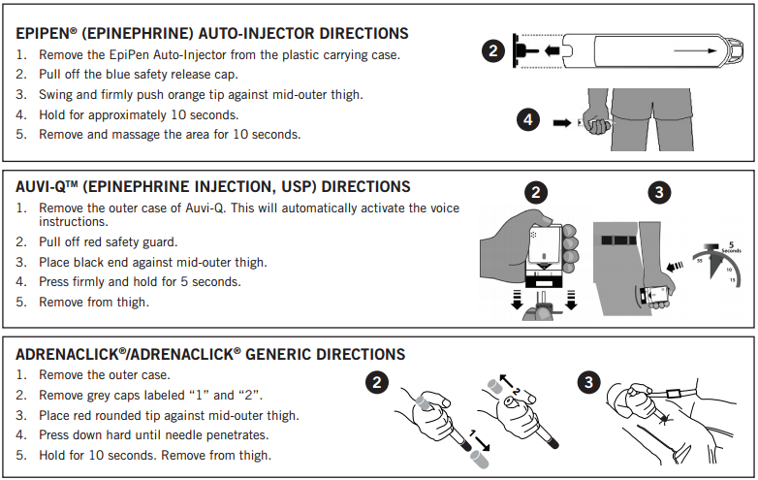

A food allergy response kit should contain at least two doses of epinephrine, other medications as noted by the student’s physician, and a copy of this action plan and treatment authorization. A kit must accompany the student if he/she is off school grounds (i.e., field trip).

Treat the person before calling emergency contacts. The first signs of a reaction can be mild, but symptoms can get worse quickly.

EMERGENCY CONTACTS:

Name/Relationship: ___________________________________________ Phone:__________________________
Name/Relationship: ___________________________________________ Phone:__________________________
Name/Relationship: ___________________________________________ Phone:__________________________

I hereby authorize for school personnel to take whatever action in their judgment may be necessary in providing emergency medical treatment consistent with this plan, including the administration of medication to my child. I understand the Virginia School Health Guidelines, Code of Virginia, 8.01-225 protects school staff members from liability arising from actions consistent with this plan.

__________________________________________ ______________________ ___________________
Parent / Guardian Signature Telephone Date

PARENT INFORMATION ABOUT MEDICATION PROCEDURES

- In no case may any health, school, or staff member administer any medication outside the framework of the procedures outlined here in the Office of Catholic Schools Policies and Guidelines and Virginia School Health Guidelines manual.

- Schools do NOT provide medications for student use.

- Medications should be taken at home whenever possible. The first dose of any new medication must be given at home to ensure the student does not have a negative reaction.

- Medication forms are required for each Prescription and Over the Counter (OTC) medication administered in school.

- All medication taken in school must have a parent/guardian signed authorization. Prescription medications, herbals and OTC medications taken for 4 or more consecutive days also require a licensed healthcare provider’s (LHCP) written order. No medication will be accepted by school personnel without the accompanying complete and appropriate medication authorization form.

- The parent or guardian must transport medications to and from school.

- Medication must be kept in the school health office, or other principal approved location, during the school day. All medication will be stored in a locked cabinet or refrigerator, within a locked area, accessible only to authorized personnel, unless the student has prior written approval to self-carry a medication (inhaler, Epi-pen). If the student self carries, it is advised that a backup medication be kept in the clinic.

- Parents/guardians are responsible for submitting a new medication authorization form to the school at the start of the school year and each time there is a change in the dosage or the time of medication administration.

- A Licensed Health Care Provider (LHCP) may use office stationery, prescription pad or other appropriate documentation in lieu of completing Part II. The following information written in lay language with no abbreviations must be included and attached to this medication administration form. Signed faxes are acceptable.
  - Student name
  - Date of Birth
  - Diagnosis
  - Signs or symptoms
  - Name of medication to be given in school
  - Exact dosage to be taken in school
  - Route of medication
  - Time and frequency to give medications, as well as exact time interval for additional dosages.
  - Sequence in which two or more medications are to be administered
  - Common side effects
  - Duration of medication order or effective start and end dates
  - LHCP’s name, signature and telephone number
  - Date of order

- All prescription medications, including physician’s samples, must be in their original containers and labeled by a LHCP or pharmacist. Medication must not exceed its expiration date.

- All Over the Counter (OTC) medication must be in the original, small, sealed container with the name of the medication and expiration date clearly visible. Parents/guardians must label the original container of the OTC with:
  - Name of student
  - Exact dosage to be taken in school
  - Frequency or time interval dosage is to be administered

- The student is to come to the clinic or a predetermined location at the prescribed time to receive medication. Parents must develop a plan with the student to ensure compliance. Medication will be given no more than one half hour before or after the prescribed time.

- Students are NOT permitted to self medicate. The school does not assume responsibility for medication taken independently by the student. Exceptions may be made on a case-by-case basis for students who demonstrate the capability to self-administer emergency life saving medications (e.g. inhaler, Epi-pen).

- Within one week after expiration of the effective date on the order, or on the last day of school, the parent or guardian must personally collect any unused portion of the medication. Medications not claimed within that period will be destroyed.

